Cloze Answers.
Monday 11th January 2021
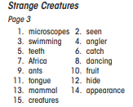

Tuesday 12th January 2021
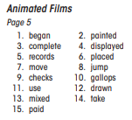
Wednesday 13th January 2021
