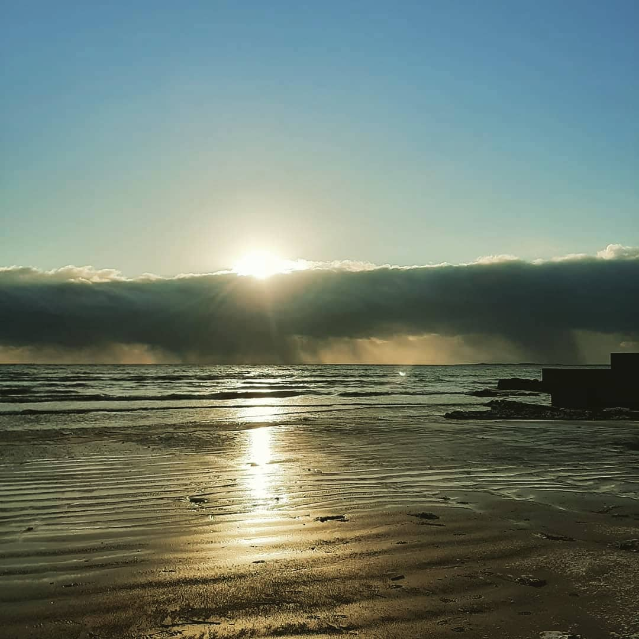

Dear Parents, guardians and friends of Thornleigh

I hope you had a chance to get out safely in the lovely sunshine this weekend. It was nice to enjoy after the dark days we have had. The longer daylight is also great to see and experience.

Last week we had a week long evaluation of Remote Teaching and Learning. The school received fabulous feedback with regard to Leadership of the Principal and the amazing teaching and learning by all the Teachers and the support of SNAs.

This morning we welcomed back our Junior to 2nd class students and it was lovely to see their smiling faces and indeed yours too. They have had a great day at school.

Have a lovely week.

Paula Juliet Carolan
Príomhoide
1st March 2021.

