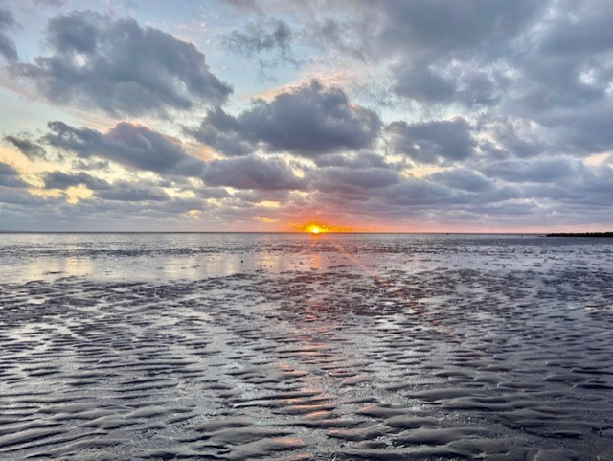

Good morning all

It was great to see all the children and some of yourselves back in school today. We are heading the right direction.

This week’s theme is ‘positivity’ and aiming to share at least one positive word or thought each day. It can be as simple as the way we say something. For example – we can say ‘it is a lovely day today’ without adding on ‘but it might rain later.’ This helps our brain to change how we view the world and the environment around us.

For the parents and guardians of 6th class. Our graduation will be on the 24th of June in the school yard at 10am. More details to follow after Easter.

Enjoy your first free day of home-schooling – you deserve it – you all did a great job. A BIG THANK YOU from myself and all the staff at Thornleigh. Your input really helped to make the experience more positive and productive for your children.

Paula Carolan – Príomhoide 15th March 2021.

