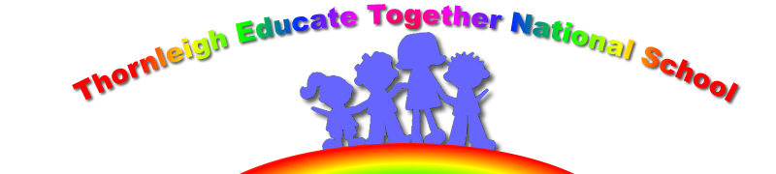

13th January 2021

Dear Parents and Guardians and pupils of Thornleigh

It was lovely to see some of you over the last few days and chat with you about how you are all getting on and your concerns. It was also an advantage to be able to put some of concerns and fears to rest. If you have any concerns please do not hesitate to contact us and we will do our best to support you.

By now the majority of you will have your books. This is a great improvement for both teachers and students alike from the first lockdown. We are in a position to have done this, this time, as we had time to review and reflect.

Tomorrow morning at 9am we go online. We are all looking forward to it here and from what parents have said you our pupils are also looking forward to it. So what can you expect?

- A link has been sent to you all from the teachers to login to Google Classroom
- Live lessons
- Activity packs
- Recorded ;lessons
- Video reading by teachers
- Video recording explaining how to engage in a lesson
- Literacy lessons
- Numeracy lessons
- SPHE lessons
- PE lessons
- Well-being lessons
- Reading Recovery lessons
- And lots more
Tune into Cúla 4 on TG4, RTE school hub, BBC schools hub, Joe Wicks for PE, Planet Earth, GoNoodle and Cosmic Kids.
Good luck with the online learning and hopefully with the introduction of the vaccination we will see you all soon.

I will keep you updated weekly and sooner if necessary as to what is happening in the Education sector.

Stay well, stay safe.

Is mise

Paula Juliet Carolan – Príomhoide.

