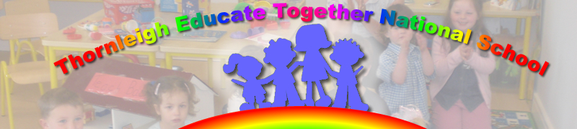

Dear Parents

I hope you and your families are all managing to navigate safely this current wave of the pandemic. I hope you enjoyed the Monday Mindfulness and that your children are enjoying Google Classroom. As always please get in touch should you require anything.

With regard to opening schools for children with significant care needs we are currently watching announcements from The Department of Education, INTO (union of teachers) NAMSE (Special Education) Fórsa (SNA union) and other stakeholders in education. I will keep you updated as soon as I have any news and indeed clear guidance on a partial opening.

Please note this will be an ‘emergency’ partial re opening and not a full return to school.

I have just left a meeting with our National Patron Body – Educate Together regarding same and have another meeting at 3.30 with Public Health. I will keep you informed.
Yours sincerely

Paula Juliet Carolan – Príomhoide 18th January 2021.

