1st February 2021

Good morning to all Parents Guardians and students of Thornleigh ETNS

Happy 1st of February, the first day of Spring and also the Christian and Catholic feast day of St Brigid. It is also a Pagan Symbol and Brigid the Goddess representing the beginning of Spring.
On this day it is customary for families and children from of this faith to make a St Brigid’s cross from rushes and hang it in your home for protection, peace and goodwill. People also put it in barns to take care of their animals. The crosses can also me made from , strips of paper, pipe cleaners or soft cardboard.
Please follow this link if you are interested in finding out more about making crosses, St Brigid and Brigid the Pagan Goddess.
https://www.youtube.com/watch?v=bq0ci42PnLc

https://www.youtube.com/watch?v=t1qY0huxkLs

https://www.google.com/search?q=making+a+st+brigids+cross+from+paper&rlz=1C1GCEA_enIE922IE922&oq=making+a+st+brigids+cross+from+paper&aqs=chrome..69i57j0i22i30j0i390.12660j1j15&sourceid=chrome&ie=UTF-8

I hope you enjoy this little piece of Irish, Christian and Pagan history and folklore.
As of yet we have no firm date for return to school but it will not be February.
Inside Out 2015 Full Movie HD - Animation Movies 2020 Full Movies English - Cartoon Disney - YouTube (press ctrl and click)
This week is also Children’s Mental Health Week and the teachers have incorporated this into their weekly. If you can access the link of Inside Out, on some of the teachers’ class pages, it is a great movie in facilitating children dealing with their emotions and especially the difficult ones which they might tend to hide or worse still ignore.
Please see below a list of useful resources on to assist you in supporting your child’s learning at home.

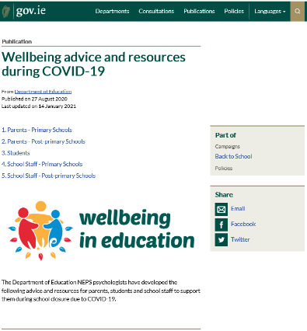

The Department of Education National Educational Psychology Service (NEPS) have many resources that you may find useful while the school is closed. These resources can be found on the Department website here

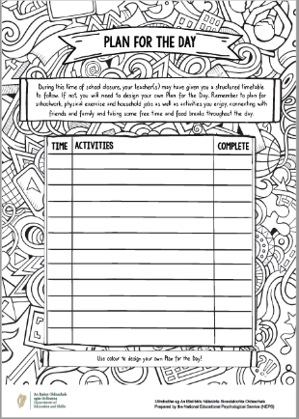
Plan for a Day
A plan for the day template is available here to help you and your child put a structure on the day. It suggests trying to have a schedule, creating time for fun activities, time for learning, break times and time for physical activity.

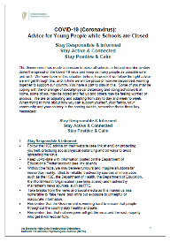
Advice for Young People
NEPS has published Advice for Young People while Schools are Closed which is available here

Relaxation Techniques Podcast
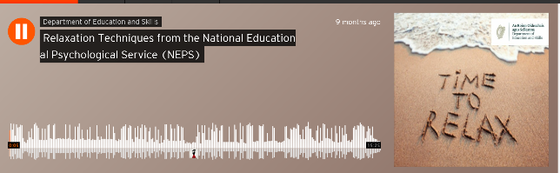
This link will take you to a podcast from NEPS to help parents and pupils practise relaxation techniques.

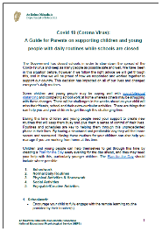
Advice for Parents
NEPS has also published A Guide for Parents on Supporting Children and Young People with Daily Routines while Schools are Closed which is available here

A Whistle-stop Tour of NEPS Wellbeing Resources for Covid19 - YouTube

Have a great week.

Yours sincerely

Paula Juliet Carolan - Príomhoide

