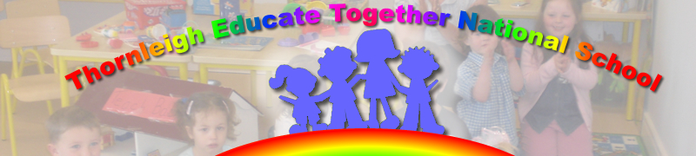

Dear Parents and Guardians

Update on book collection

In the event that it is raining this week the following is the alternative plan for collection of books

Please enter the school through the gate at the side of the yard – all parents must wear masks – no mask no entry. Children may not collect books as according to NPHET – new strain of Covid 19
‘may infect children more easily’.
The books can be collected at the following doors

4 door collection points | Bottom PE hall door | Top PE hall Door (next to parents’ room) | Parents’ room door | Door leading into school closest to parents’ room door
Staff member supervising | Antoinette | Paula | Paddy | Siobhán
11th January 2021 | John’s Junior Infants  11- 12 | Avril’s Junior Infants  11-12 | Brian’s Senior Infants  11-12 | Cathal’s Senior Infants  11-12
 | Laura’s First Class  12.30 – 1.30 | Ellyn’s First Class  12.30 – 1.30 | Katie’s 2nd Class  12.30 – 1.30 | Séan’s 2nd class  12.30 – 1.30
12th January 2021 | Aoibheann’s 3rd class  11 - 12 | Quinn’s 3rd class  11-12
 |  | Cathyann’s 4th class  1-2  Paula/Antoinette | Matt’s 4th class  1-2pm | Fiona’s 4th class  1-2pm
Wednesday 13th of January 2021 | Karen’s 5th class  11-12 | Ryan’s 5th class  11-12 | Maurette’s 6th class  1-2 | Róisin’s 6th class  1-2

Parents form a line keeping a 2 metre social distance at all times. Ground is marked at 1 metre distance therefore cones will be placed at 2 metre distance – please do not disregard this rule – it is to protect all parents/guardians and school staff.

Again please do not congregate, but rather collect books and head home. If your books are not collected, we will take them back in and you can contact Paddy or myself to make alternative arrangements.

Once again thank you for your cooperation and flexibility

Yours sincerely

Paula Juliet Carolan – Príomhoide 10th January 2021

